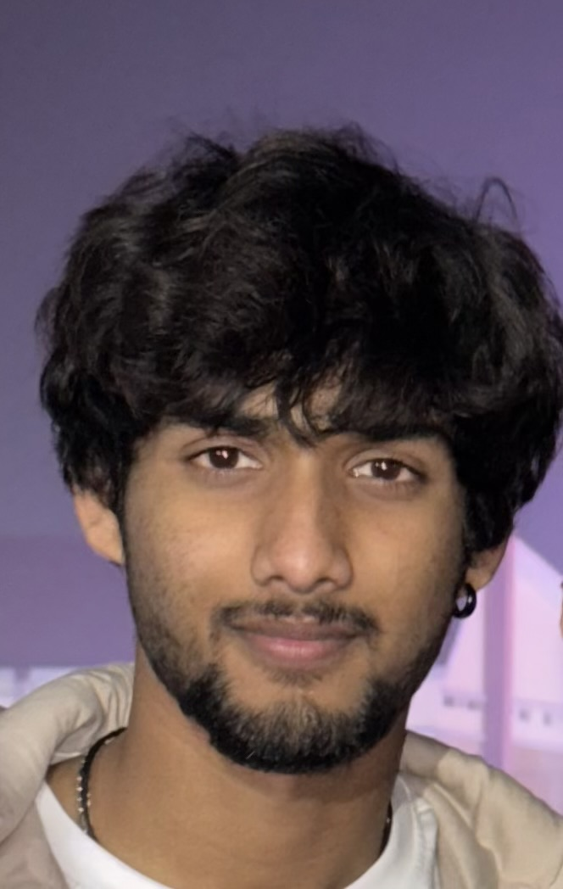

Anush Karanapu

*Phone: 8767321250 | Email: karanapuanush@gmail.com*

*LinkedIn: linkedin.com/in/anush-karanapu | GitHub: github.com/Anush0088*

# Career Objective

*I am currently developing my skills in software development, with a focus on AI/ML and full-stack technologies. I’m passionate about turning ideas into functional solutions and continuously improving through hands-on learning. Looking forward to contributing meaningfully to real-world projects while building my portfolio.*

# Education

*VIT Bhopal University  
B.Tech in Computer Science and Engineering (AI & ML Specialization)  
Passing Year: 2027 | CGPA: 7.2*

*Sri Chaitanya Institution, Vijayawada – Higher Secondary*

*St. Thomas English Medium School, Solapur, Maharashtra – Secondary (ICSE)*

# Skills

*- Programming Languages: C++, Java, Python  
- Tools & Technologies: VS Code, Git, Google Colab  
- Soft Skills: Strong communication, Leadership, ICSE foundation*

# Projects

*1. Text-to-Image Converter  
A tool that converts descriptive text into images using AI models.*

*2. Brain Cancer Detection using Deep Learning  
Implemented a CNN model to detect cancer from MRI images.*

*3. House Price Prediction  
Used Linear Regression in an AI/ML model to estimate housing prices*.

# Achievements & Certifications

*- Python Programming by VITyarthi (2023)*

*- Fundamentals of AI/ML by VITyarthi (2024)*

*- Cloud Computing by NPTEL (2025)*

*- Currently learning MERN Full Stack Web Development (Project to be uploaded soon)*

# Extra-Curricular Activities

*- Dance*

*- Athletics*

*- Swimming*

*-Playing Guitar*